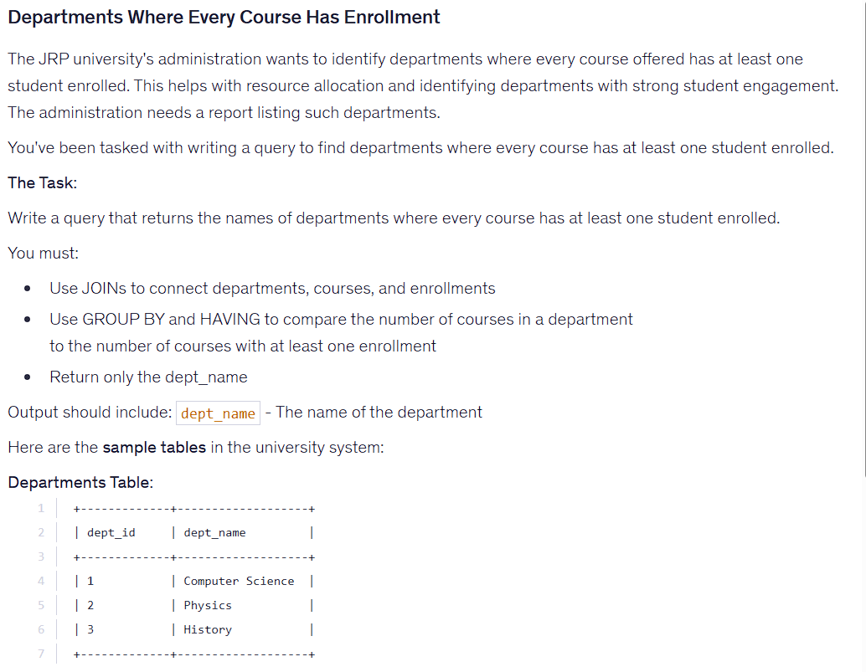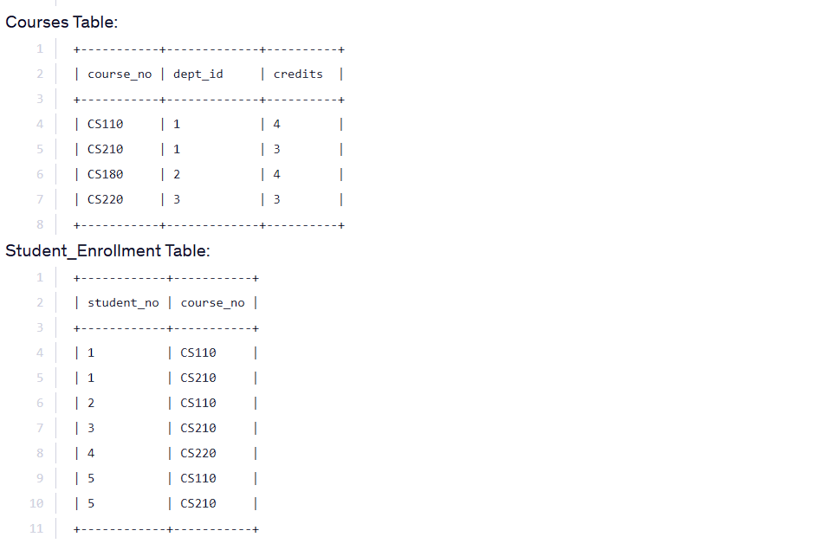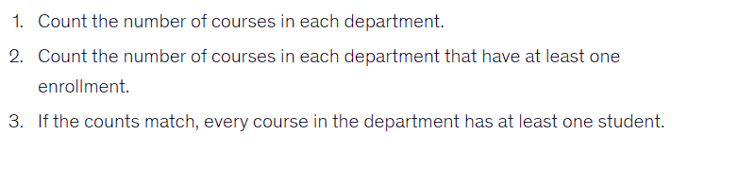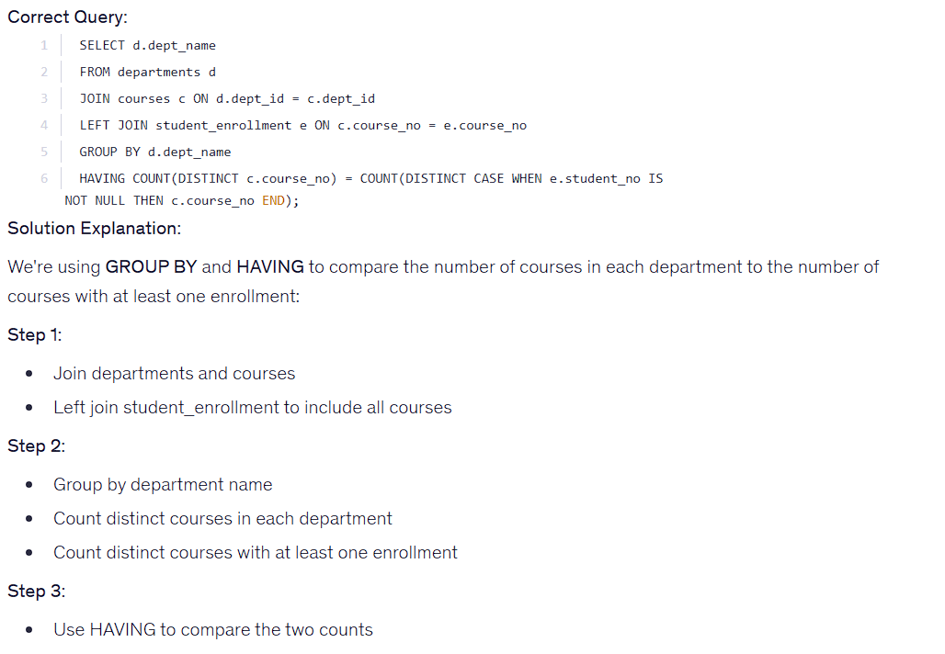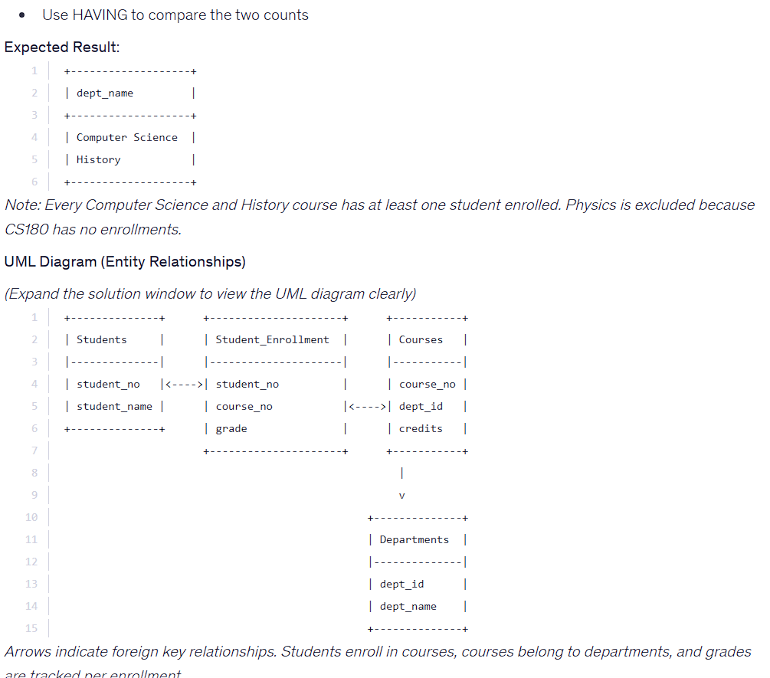

SELECT d.dept_name
FROM departments d
JOIN courses c ON d.dept_id = c.dept_id
LEFT JOIN student_enrollment e ON c.course_no = e.course_no
GROUP BY d.dept_name
HAVING COUNT(DISTINCT c.course_no) = COUNT(DISTINCT CASE WHEN e.student_no IS NOT NULL THEN

